**Experiment No: 10**

**Aim:** To explain continuous monitoring and installation and configuration of Nagios Core, Nagios Plugins and NRPE (Nagios Remote Plugin Executor) on Linux machine.

**LO1:** To explain DevOps practices and cloud native environments to achieve continuous software delivery pipelines and automated operations that address the gap between IT resources and growing cloud complexity.

**LO5:** To describe various troubleshooting techniques by monitoring your entire infrastructure and business processes.

**Theory:**

Continuous monitoring is a crucial process in IT infrastructure management, ensuring that systems, networks, and applications are continuously evaluated for performance, availability, and security issues. Nagios Core is a powerful, open-source monitoring tool used to track the status of various services, devices, and systems. It alerts administrators when a problem arises and notifies them when the issue is resolved. This helps in maintaining a healthy and optimized IT environment, preventing downtime, and ensuring smooth operations.

Nagios operates by running a series of checks on system resources and services like disk usage, CPU load, and memory usage. These checks are executed periodically, and the results are displayed on the Nagios web interface, where the system’s overall health can be viewed in real-time.

**Nagios Components:**

1. **Nagios Core:** The central engine responsible for processing checks, sending notifications, and managing monitoring.
2. **Nagios Plugins:** These are essential for performing actual checks. Each plugin monitors a specific service or resource, like disk space or CPU load, and returns the status to Nagios Core.
3. **NRPE (Nagios Remote Plugin Executor):** A tool that allows Nagios to remotely execute plugins on Linux/Unix machines, making it possible to monitor remote systems from a centralized Nagios server.

The experiment involves installing Nagios Core, Plugins, and NRPE on a Linux machine. The steps include setting up a monitoring server (Nagios Core), configuring the web interface for viewing the monitoring data, and adding remote hosts using NRPE for comprehensive infrastructure monitoring. Once configured, Nagios sends alerts via email or notifications whenever an issue, such as high CPU usage or insufficient disk space, arises. This allows for proactive response, helping administrators prevent potential system failures or outages.

**Steps:**

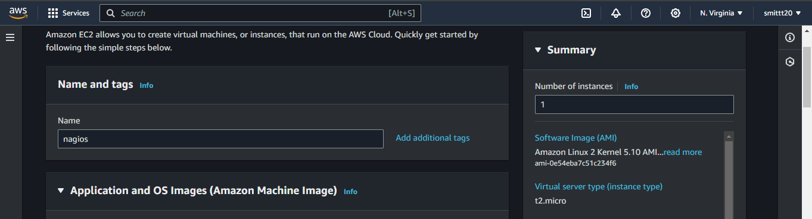

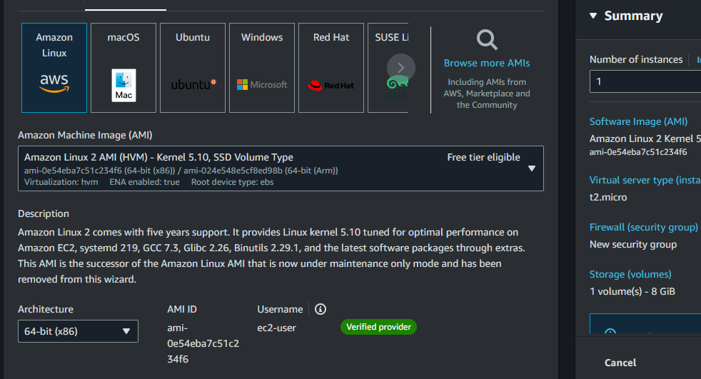

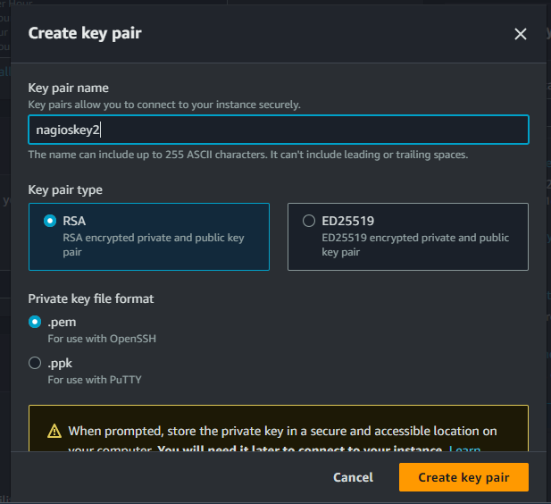

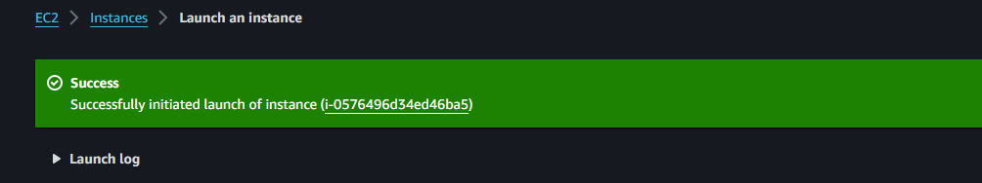

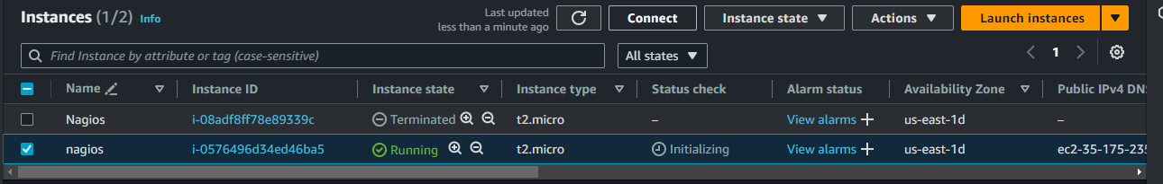

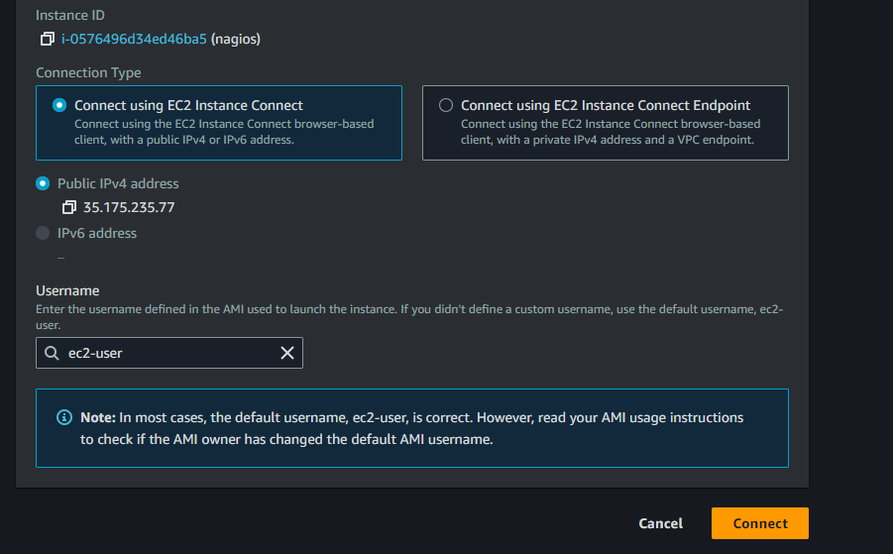

Select the instance and click connect to go to below pic

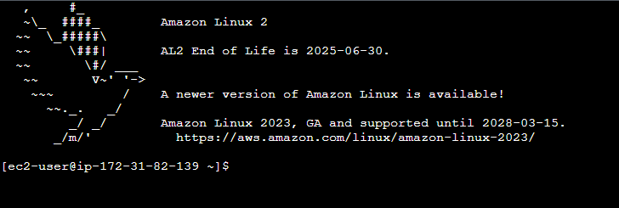

**Conclusion:** From this experiment we have learned, how to set up continuous monitoring using Nagios Core, along with the Nagios Plugins and NRPE on a Linux machine. You can now expand this by adding more services or hosts as per your monitoring needs.

**LO’s achieved:** LO1, LO5

**PO’s achieved:** PO1, PO2, PO3, PO5, PO8, PO10, PO12